3D PAWS Evaluation
Konya Site Visit: Maintenance and Condition Assessment. 1/12/2024
Tasks conducted:
Dismantled and cleaned the 3 rain gauges.
Reassembled the rain gauges and added a rain gauge stabilizer to each station.
Dismantled and cleaned the 3 radiation shields.
Changed the temperature, pressure and humidity sensors in stations 1 and 3.
Replaced the HTU 21D humidity sensor with the SHT 31D sensor in stations 1 and 3.
Swapped the cellular router and reset passwords in the 3 Raspberry Pis.
Downloaded all data from the Raspberry Pi SD cards.
- Overall Condition
All three stations appeared to be in good condition, almost 17 months after they were installed (original installation was Aug 22, 2022). The anemometers and wind vanes were all spinning freely; the inside of the data logger boxes were clean and dry; the rain gauges and radiation shields were relatively clean and appeared to be mostly level.
- Rain Gauges
The following photos are of Station 2 rain gauge but they are representative of the condition of all three gauges:
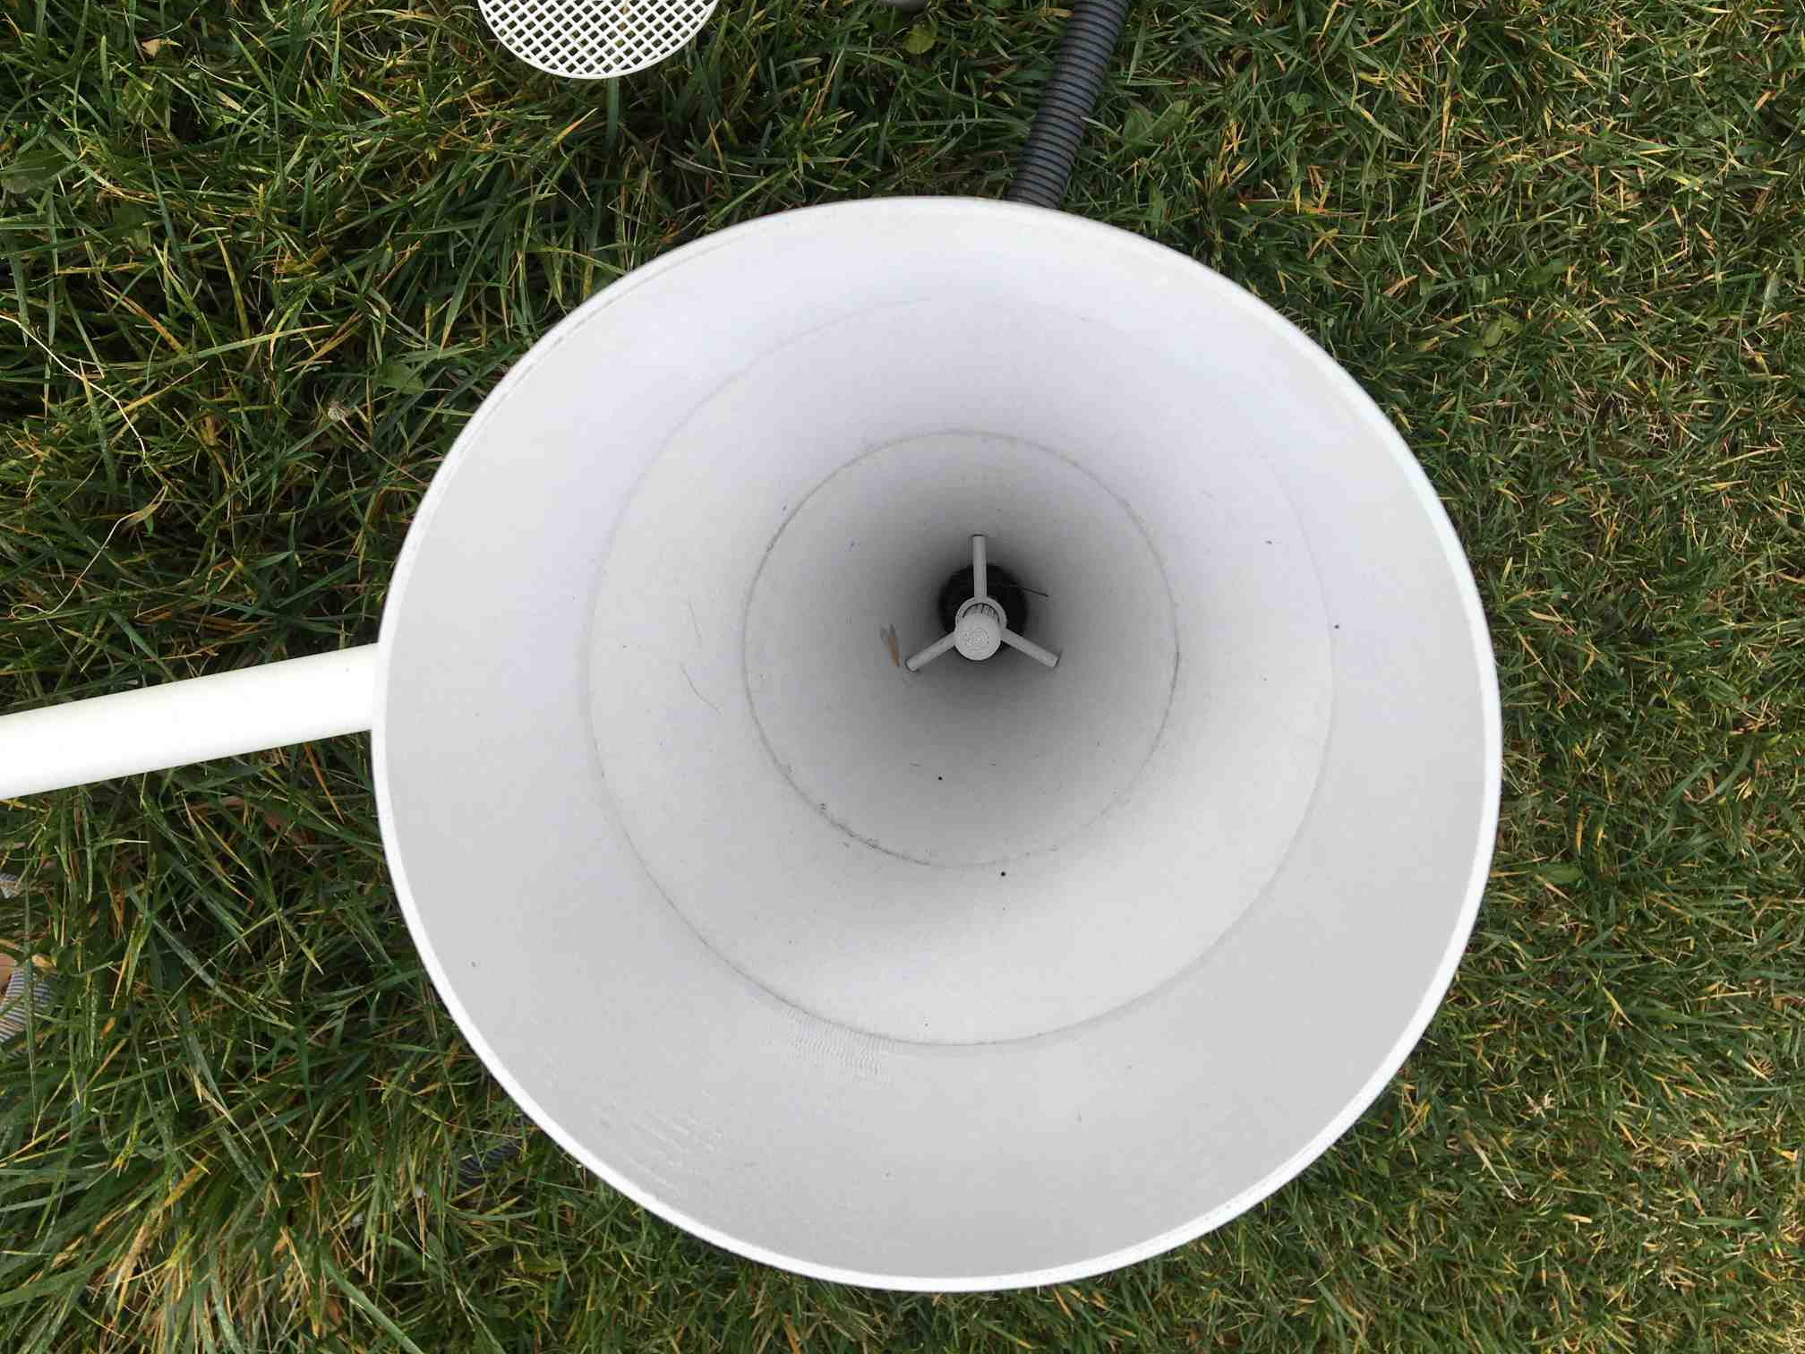
Photo 1. Station 2 rain gauge before dismantling.
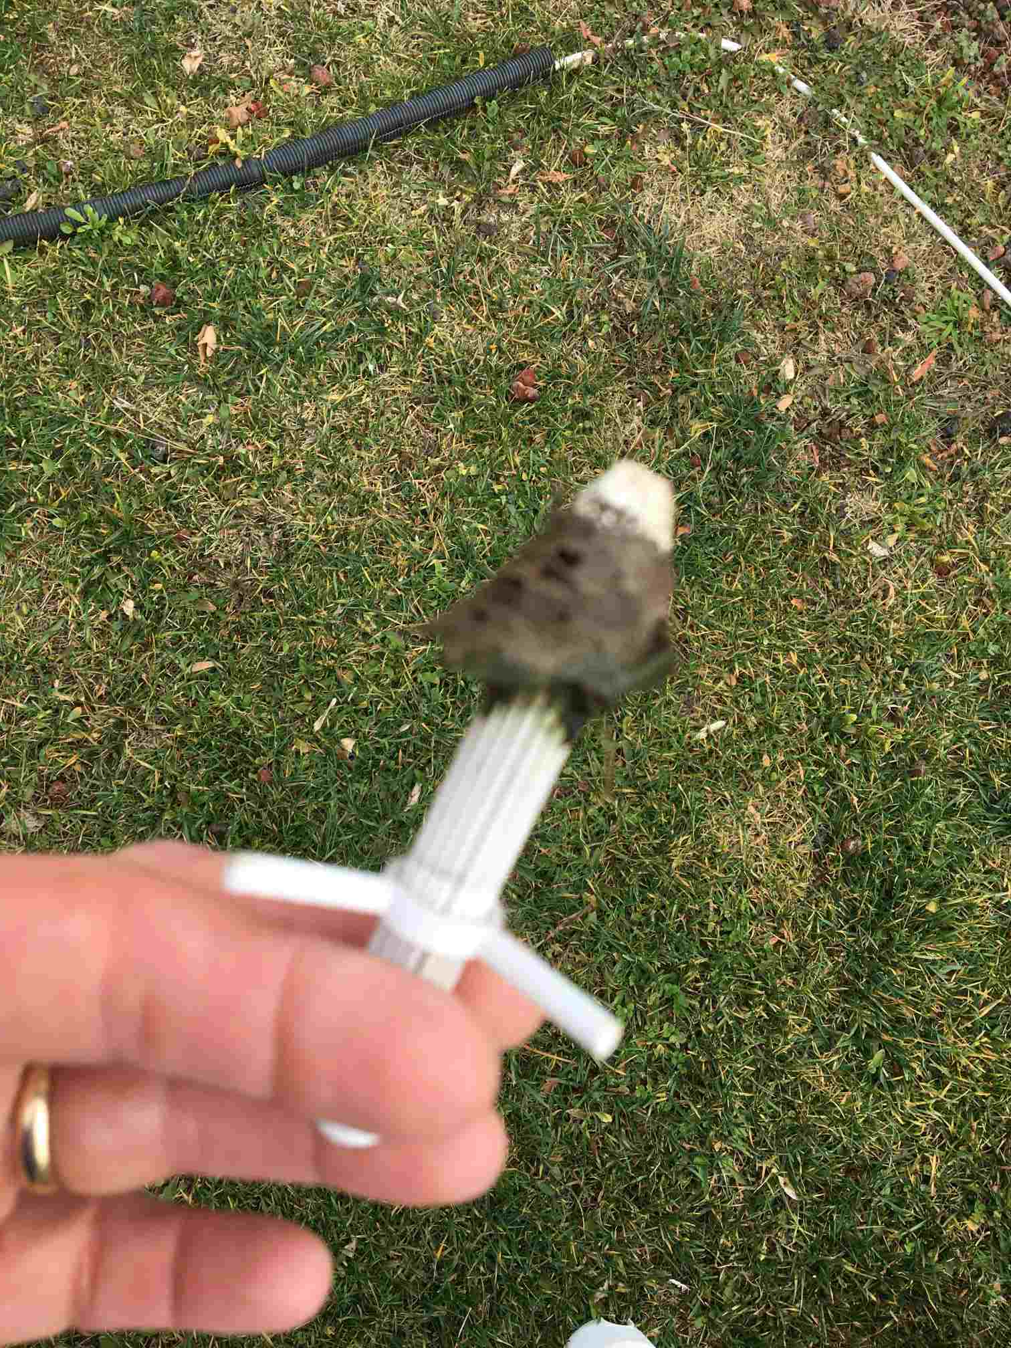
Photo 2. Station 2 vertical screen with debris
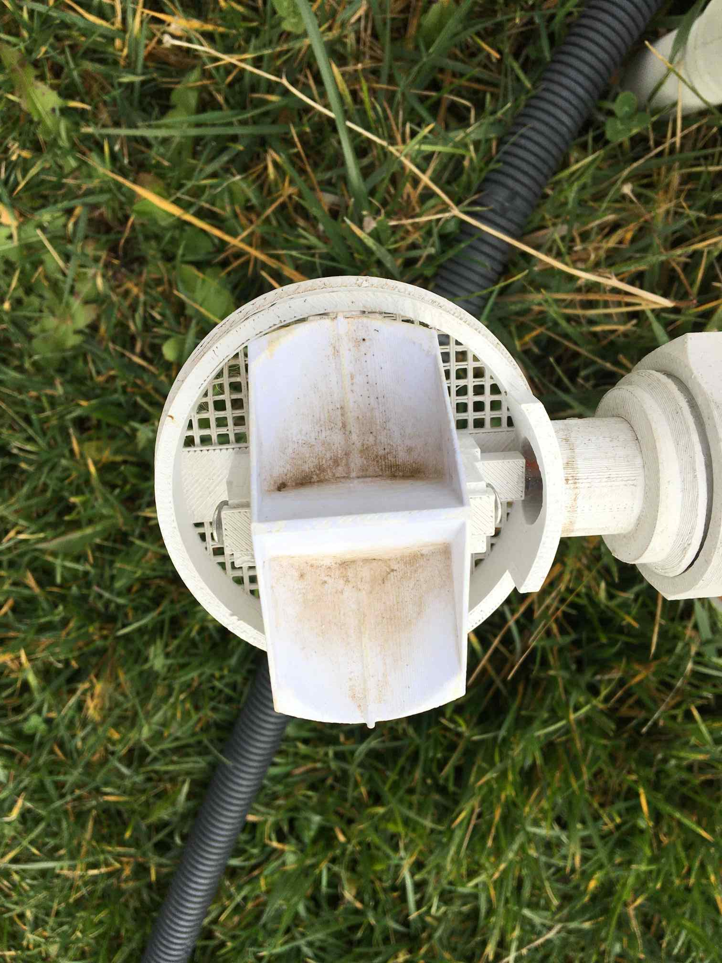.
Photo 3. Station 2 bucket before cleaning
All three rain gauges appeared to be in good condition with no mechanical issues. It was apparent that the vertical screen was performing its task well: each rain gauge had a similar 2cm deep plug of debris (mostly grass cuttings) that could possibly have blocked the funnel if there was no screen. Although the plug was holding some moisture that would not be registered by the rain gauge, rain was otherwise free to pass through the slots in the screen above the plug. The condition of the bucket also reflected the effectiveness of the screen; there was a little debris in each side of the bucket, but the amount was unlikely to have a significant impact on the performance of the gauge.
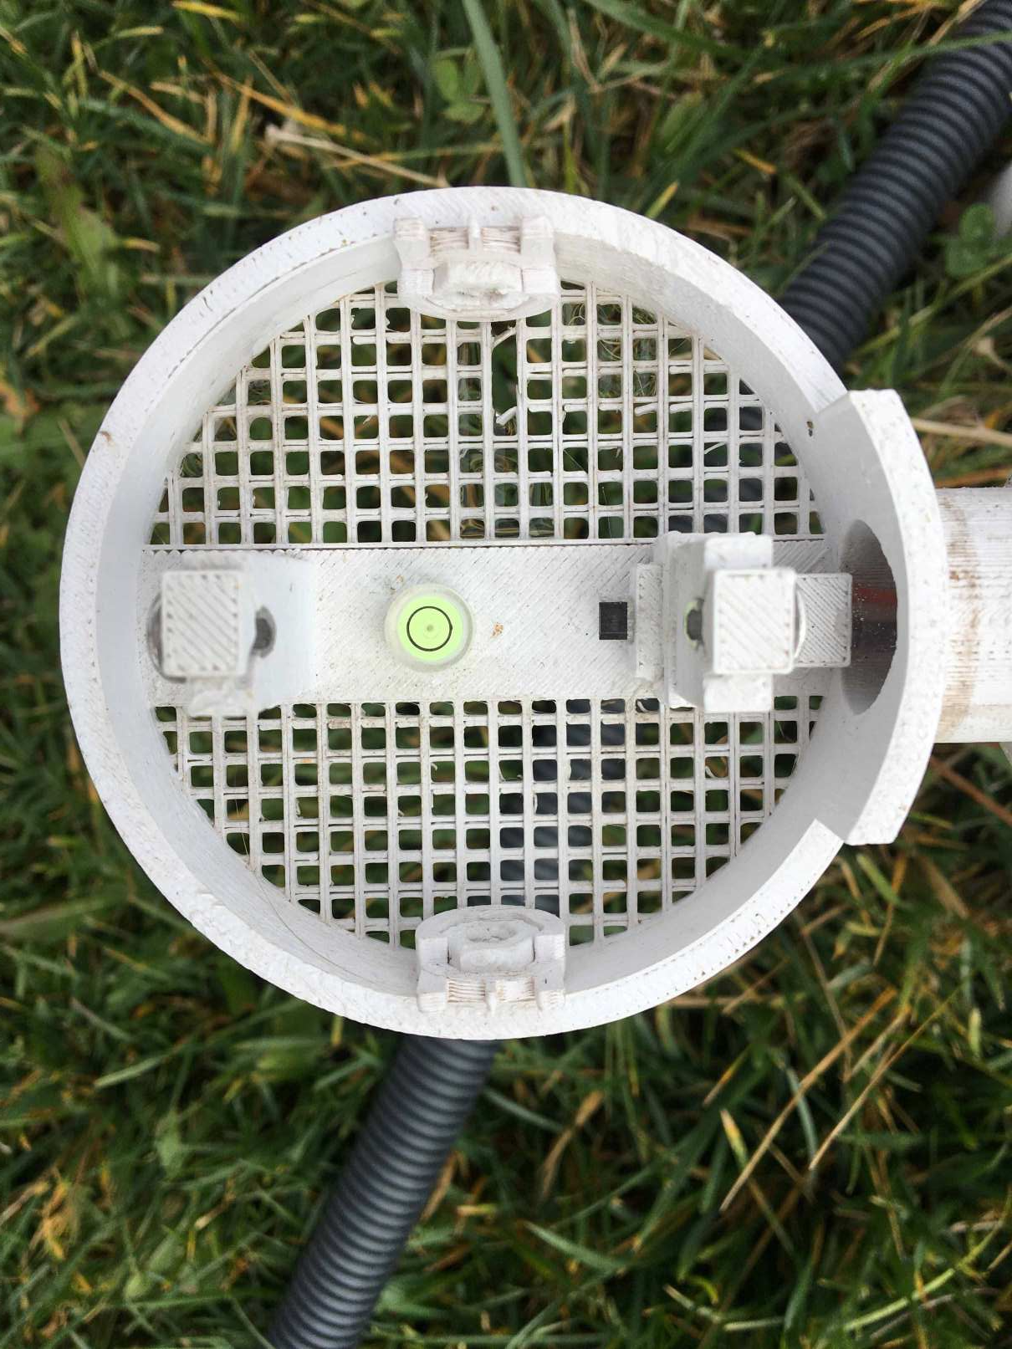
Photo 4. Station 2 level
It’s not very clear from the photo but the gauge was perfectly level, as was the gauge in Station 1. Station 3 was slightly off level (see later).
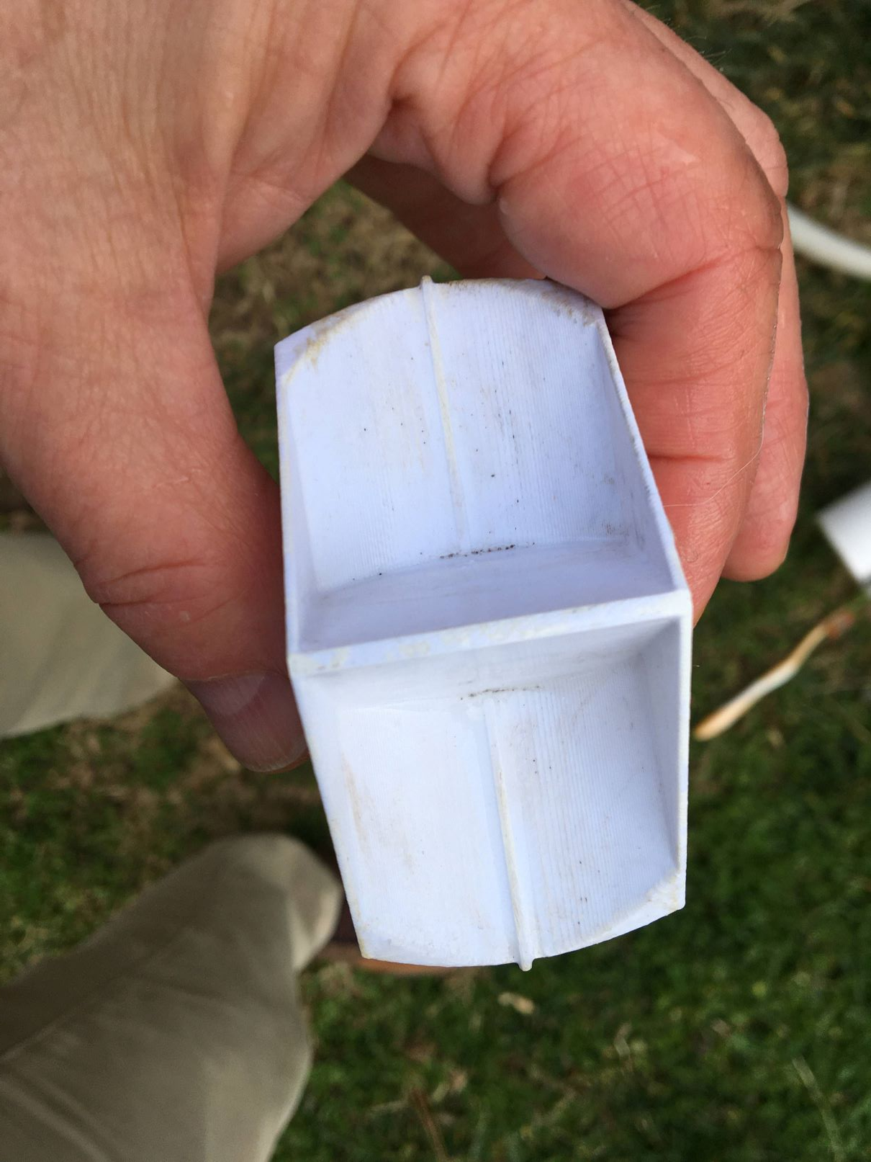
Photo 5. Cleaned bucket
A soft toothbrush was used to clean the funnel, the screen and the bucket of all three gauges; all components cleaned up well and showed no significant deterioration.
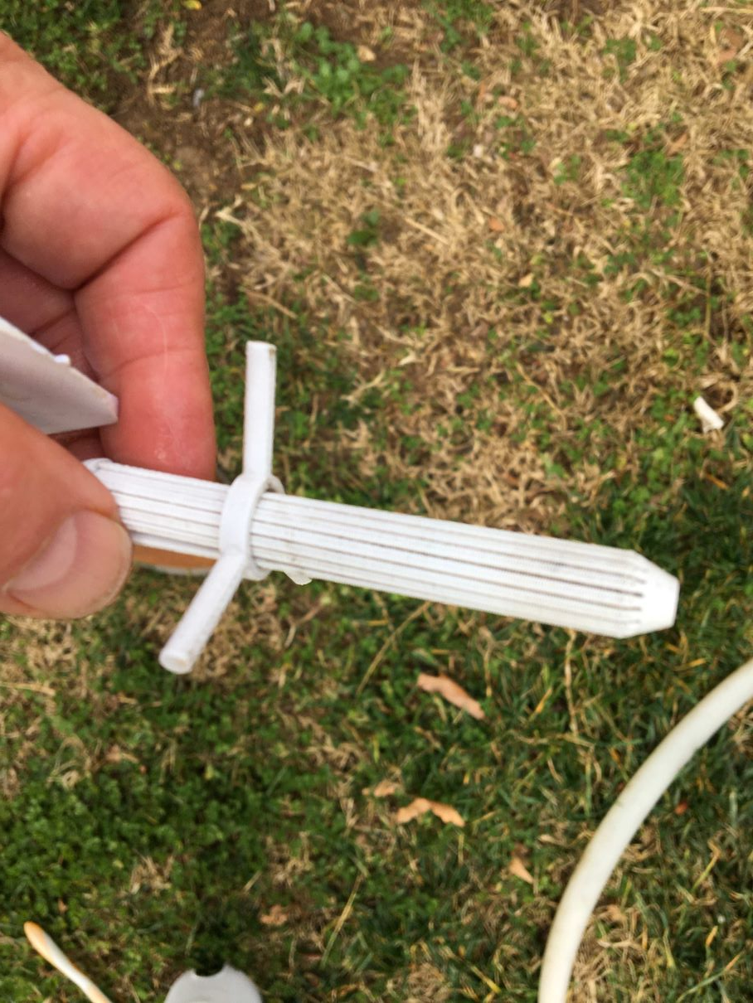
Photo 6. Cleaned screen
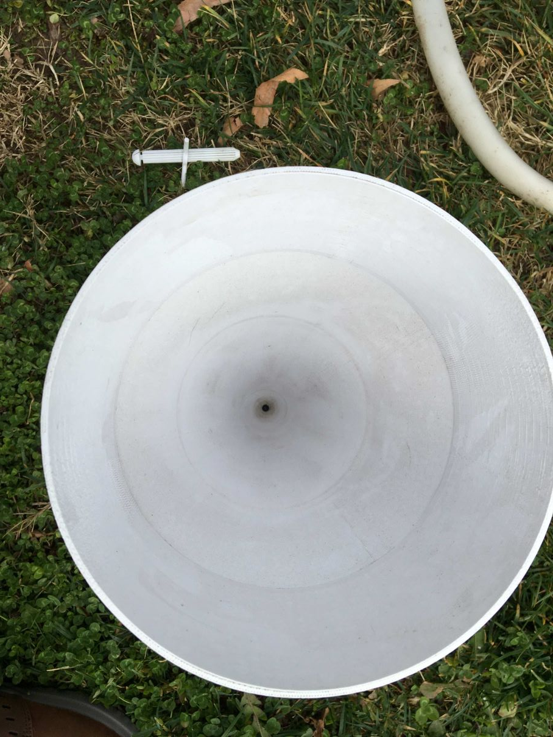
Photo 7. Cleaned funnel

- Adding Rain Gauge Stabilizers
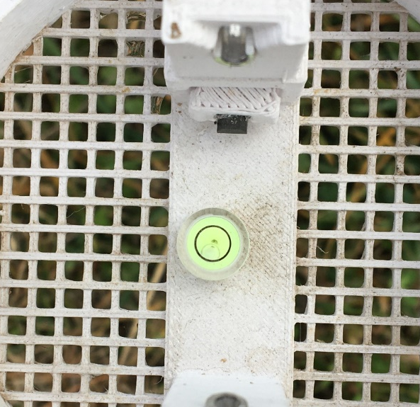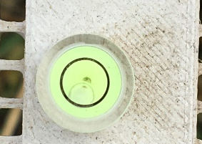
Photo 8. Gauge 3 level
Station 3 rain gauge base was found to be a little off level but the discrepancy was along the axis from front to back of the rain gauge, rather than along the tipping axis of the bucket, which would have a lesser impact on performance.
All three gauges were fitted with the new rain gauge stabilizer after they were reassembled. The stabilizers prevents loss of level due to rotation of the rain gauge about the leveling joint, which has been observed at some installations.
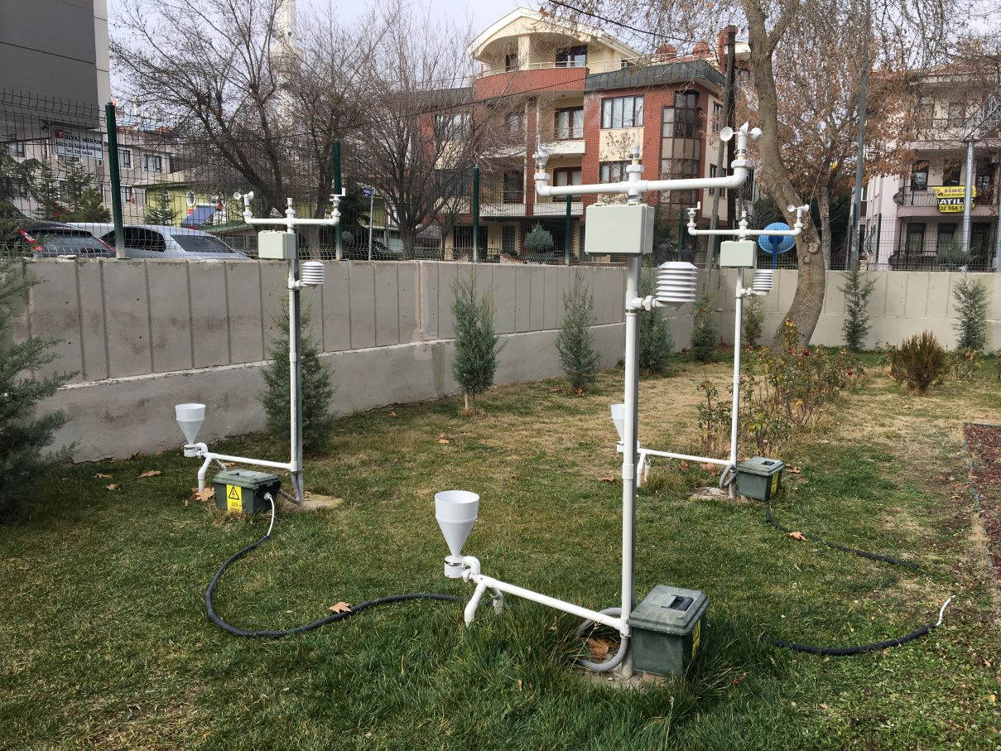
Photo 9. Gauge with Stabilizer
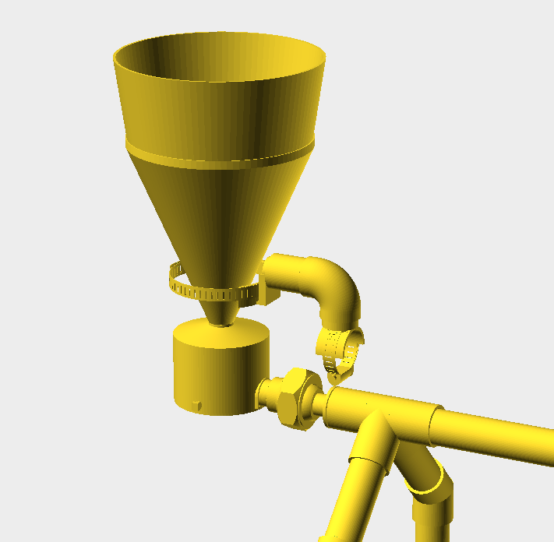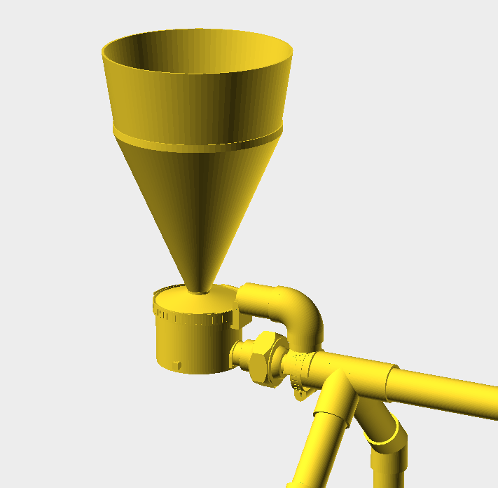
Illustration 1. Details of the Rain Gauge Stabilizer
- Radiation Shields
The following photos are of Station 1 radiation shield but they are representative of the condition of all three shields:
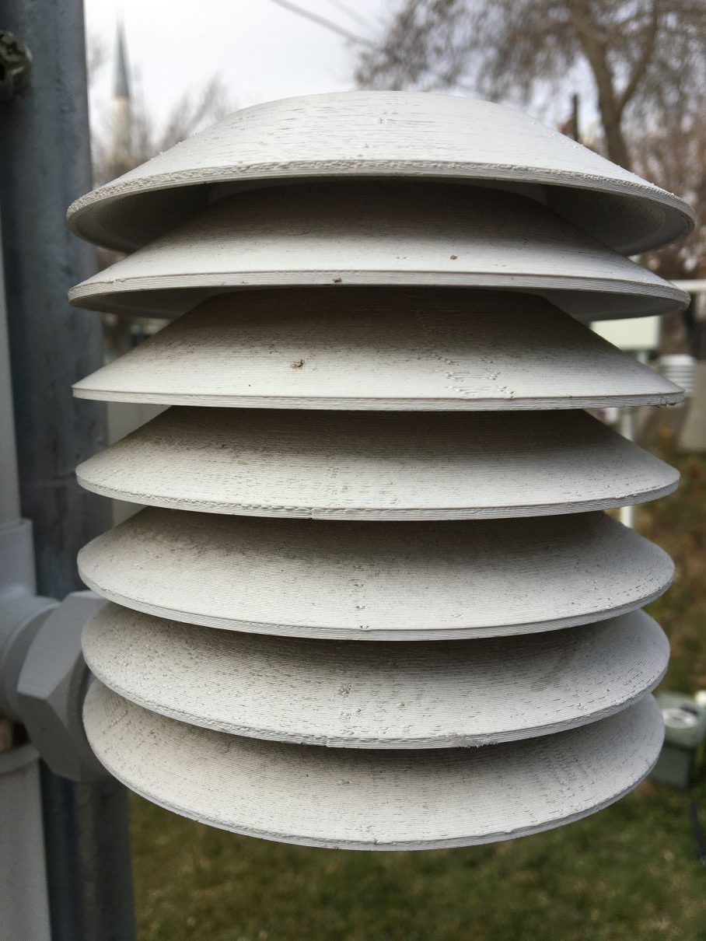
Photo 10. Radiation shield before cleaning
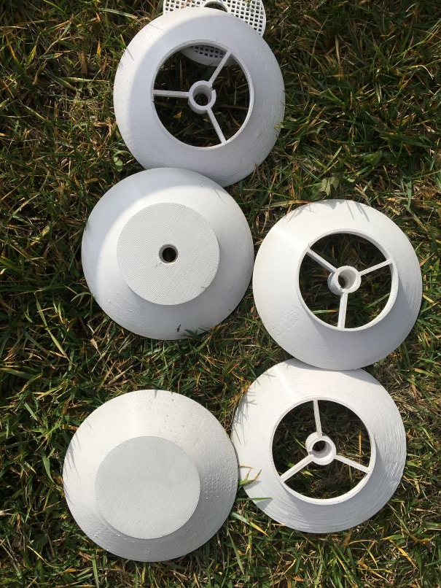
Photo 11. Radiation shield components after cleaning
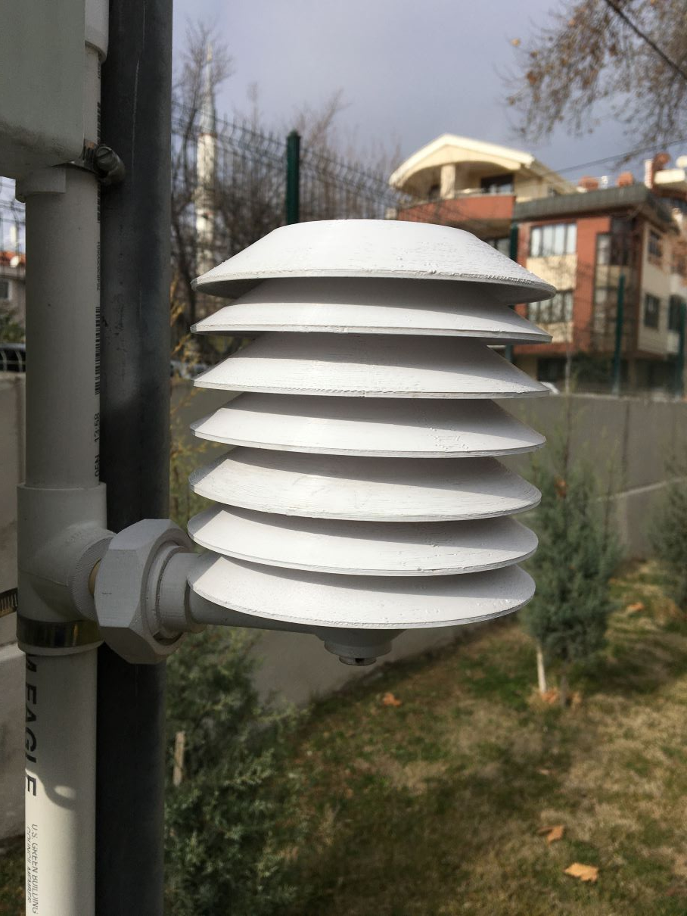
Photo 12. Reassembled radiation shield
A soft toothbrush was again used to clean the radiation shield components; all components cleaned up well and showed no significant deterioration or discoloration.
NOTE: In Station 3 radiation shield, the closed leaf had been omitted and its place taken by a sixth open leaf. This was an error in the original assembly that had been overlooked.
- Radiation Shield Harnesses
The original radiation shield harness included one MCP 9808 temperature sensor, one BMP 280 pressure/temperature sensor and one HTU 21D relative humidity/temperature sensor. A recent rudimentary comparison of data from the three sets of sensors indicated that all components were still operating as expected. An inspection of the components found that they were clean and showed little or no signs of corrosion. All the cables and connectors also appeared to be in good condition.
Given the logistical issues of conducting maintenance and that 18 months might be considered a reasonable service life for low cost sensors, it was decided that new sensors should be installed in two of the three shields, while one shield (Station 2) retained the original sensors as a bench mark and longevity test. In addition, the HTU 21D humidity sensors in Stations 1 and 3 were replaced by SHT 31D sensors. The SHT 31D is the new standard sensor for the 3D PAWS station.
- Wi-Fi router replacement
The stations in Konya are Raspberry Pi based and transmit data via Wi-Fi to a router located inside the TSMS building. The original router has recently had some connectivity issues which required a regular reboot to maintain the Wi-Fi links. A new router was installed during the visit to address this issue, which required new password settings in the Raspberry Pis.
- Data Download
All data recorded by the 3D PAWS stations are saved to an on-board SD card as a backup in case of loss of the communications link. All data that had been saved to the SD card during the last 17 months was downloaded from the Konya stations during the maintenance visit.

